# **Thyroid Disease**

# **Detection**

*Wireframe documentation*

**1. Homepage**

User can able to view the following webpage once entering into web application

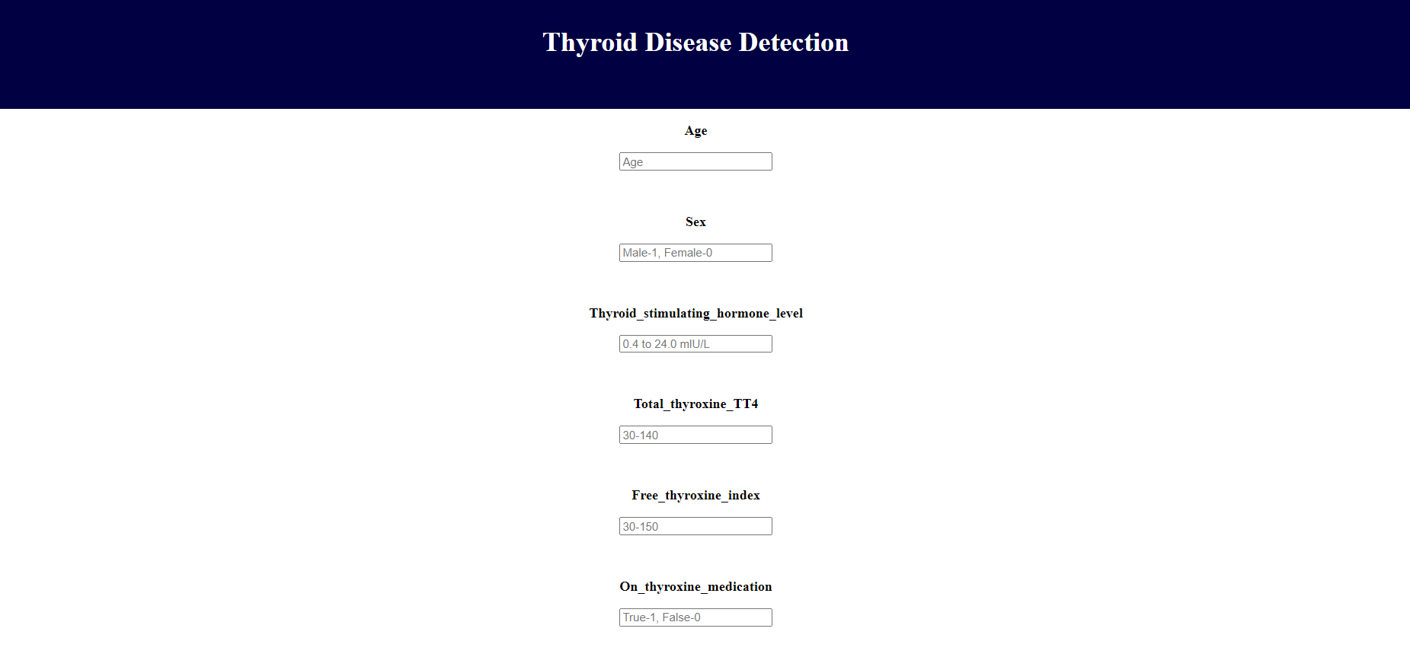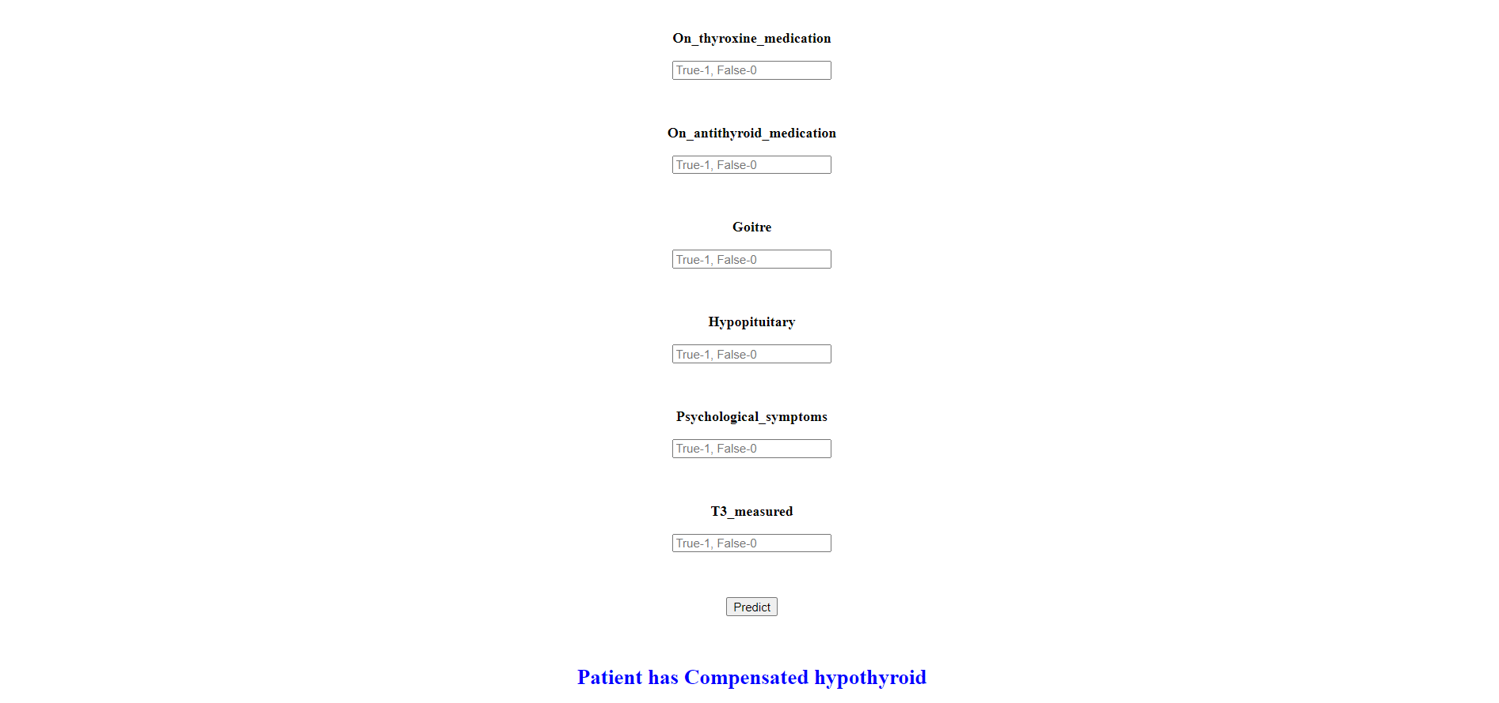

After filling the above information use able to see:

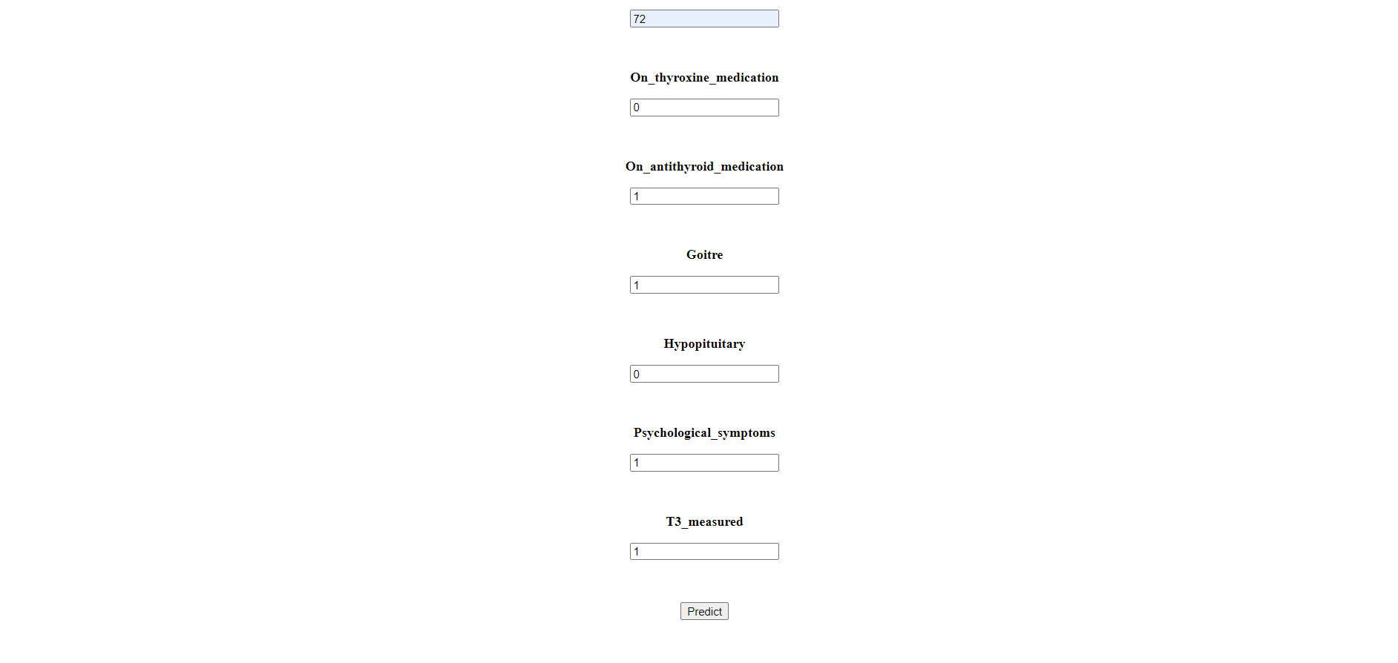

**2. Results**

After clicking on the Predict button, results will be displayed below the button



**3. Database**

The information provided by the user, will be stored in the database once the user clicks on the predict button

